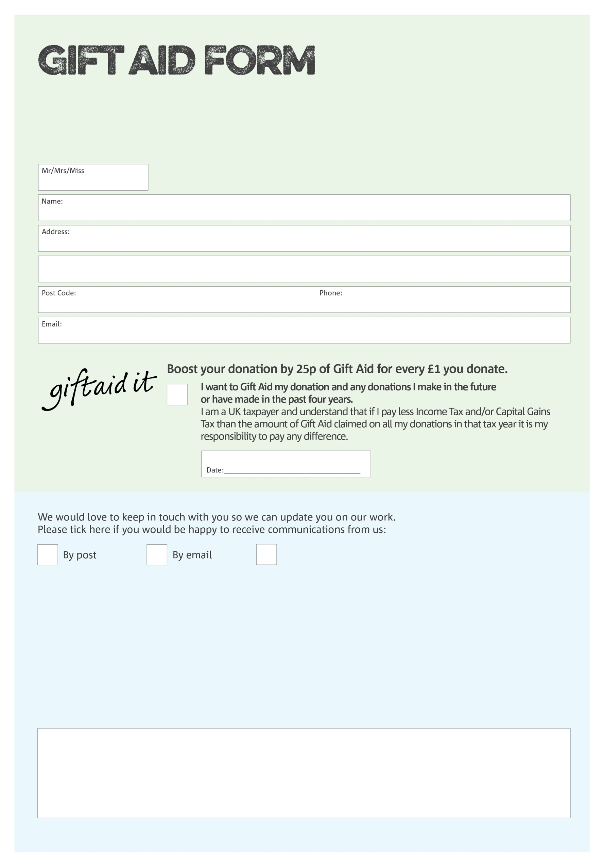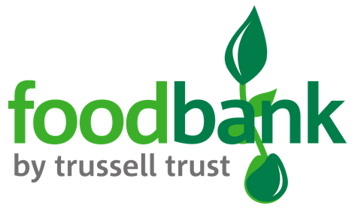

By filling in this form Clay Cross Foodbank will receive an extra 25p for every £1 you give at no extra cost to you. Thank you!

**Data protection**

Clay Cross Foodbank is committed to protecting your privacy and will process your personal data in accordance with the Data Protection Act 1998. Clay Cross Foodbank collects information to keep in touch with you and supply you with information relating to our work. Clay CrossFoodbank will never sell or pass your details to anyone who isn’t directly working on our behalf. A full data privacy statement for financial donors is available from the foodbank on request.

You can change your preferences any time by contacting us on 07899878398 or emailing us at

info@claycross.foodbank.org.uk

I do not wish to receive future communications from Clay Cross Foodbank

We would love to know why you have chosen to donate to Clay Cross Foodbank. If you would like to share your motivation let us know below:

Charity Number 247928. Registered in England and Wales