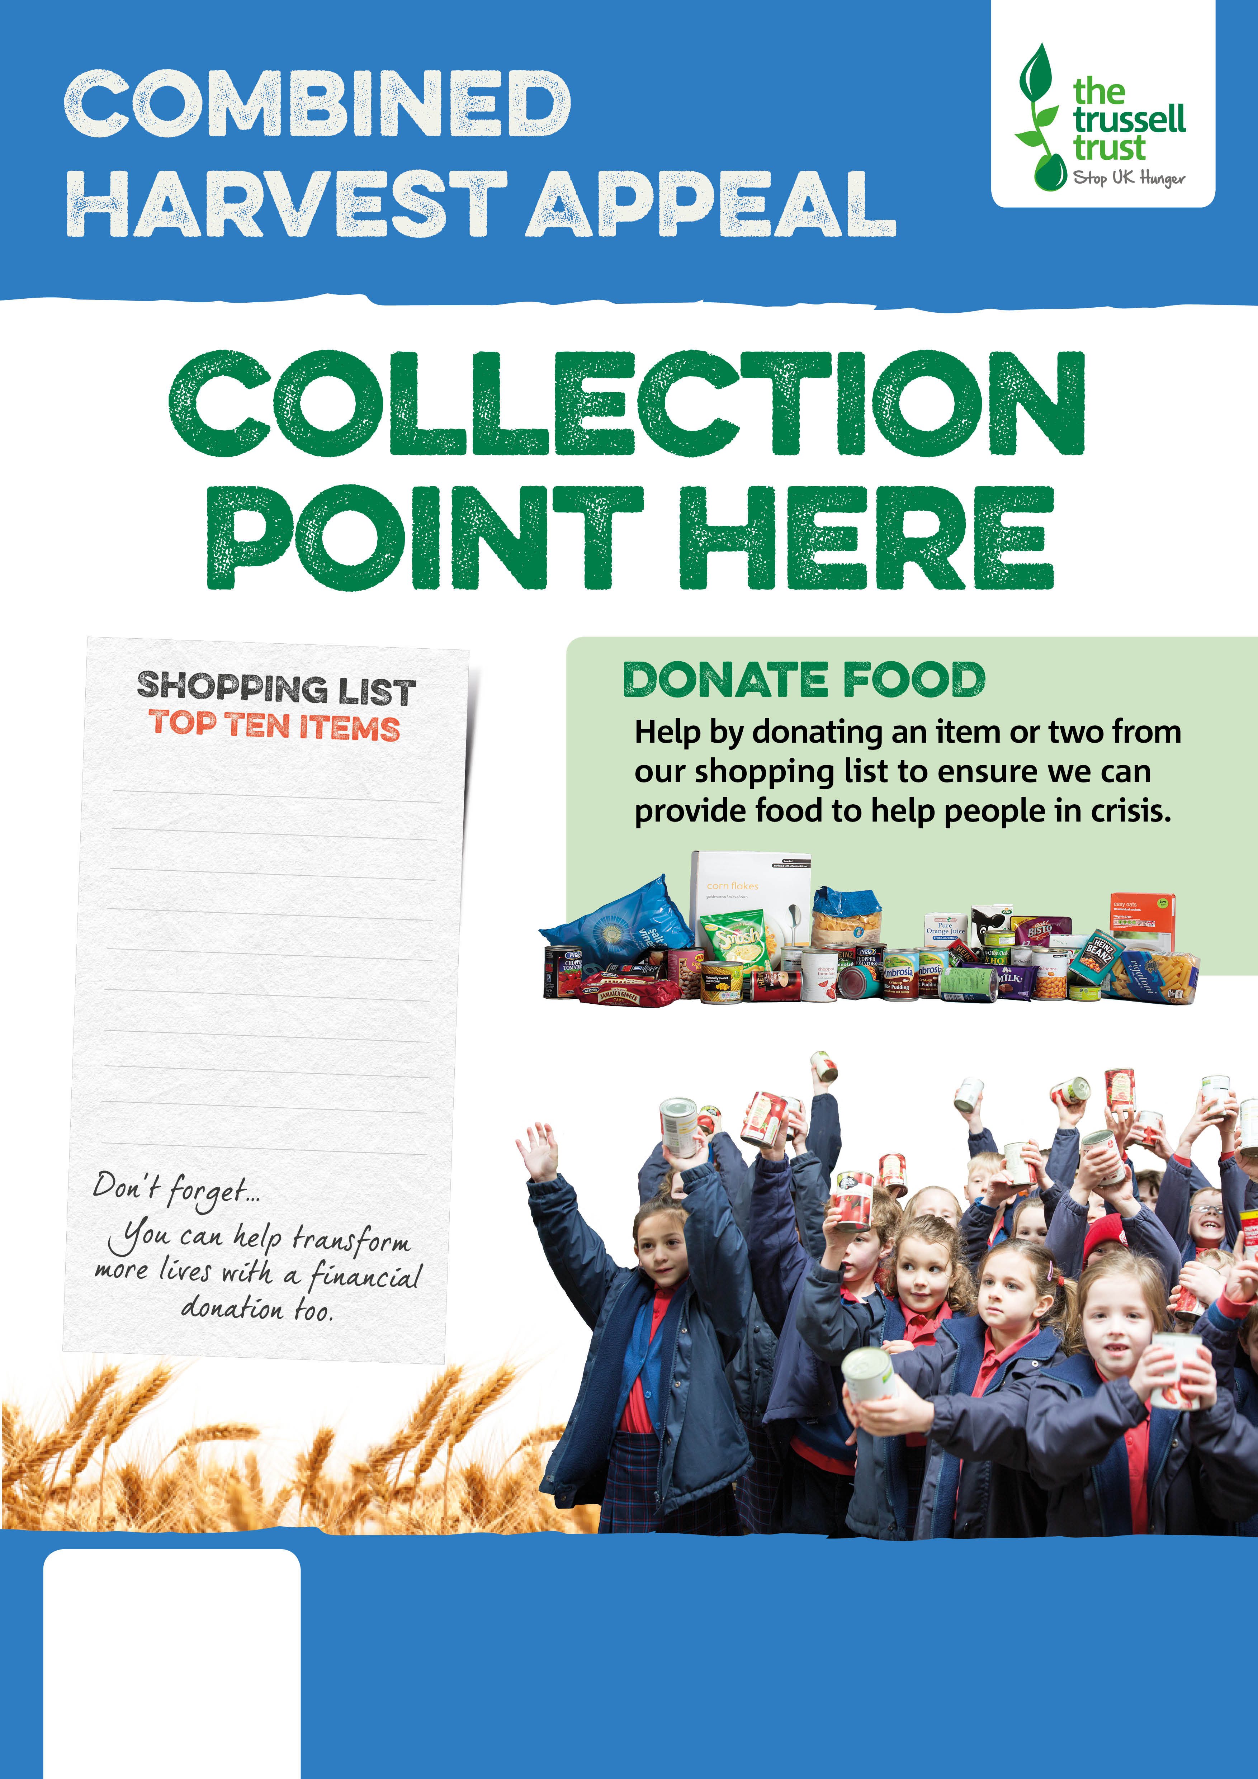

[www.claycross.foodbank.org.uk](http://www.claycross.foodbank.org.uk)

www.facebook.com/clayxfoodbank

Registered Charity in England & Wales (247928)

Soup

Rice Pudding

Long life Fruit Juice

Tinned Fruit

Tinned Fish

Instant Mash

Powdered Milk

Coffee/tea

Biscuits

Toilet Roll

