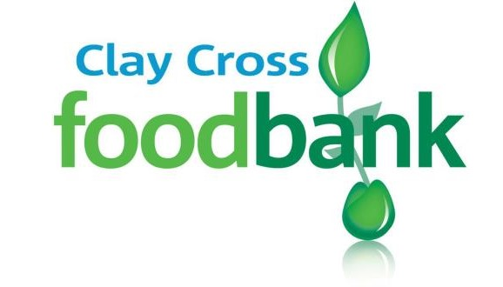
We are short of:
- Tinned fruit
- Tinned toms
- Pasta sauce
- Tinned soup
- Tinned veg
- Tinned fish
- Tinned meat
- Instant mash
- Coffee
- Long life fruit juice
- UHT milk
- Tinned rice pudding

And the following extras: mens deodorant, cat food, mens shower gel, ladies shampoo, laundry products,
adult toothbrushes

You can donate at Clay Cross Tesco, or our Foodbank sessions or contact us to arrange a time that suits you (07899878398 or info@claycross.foodbank.org.uk)

