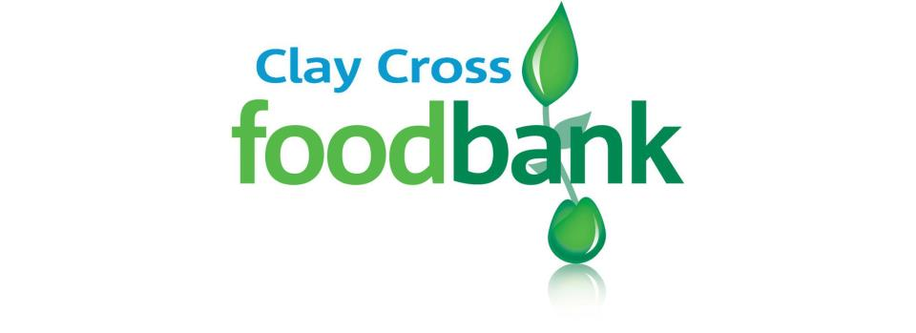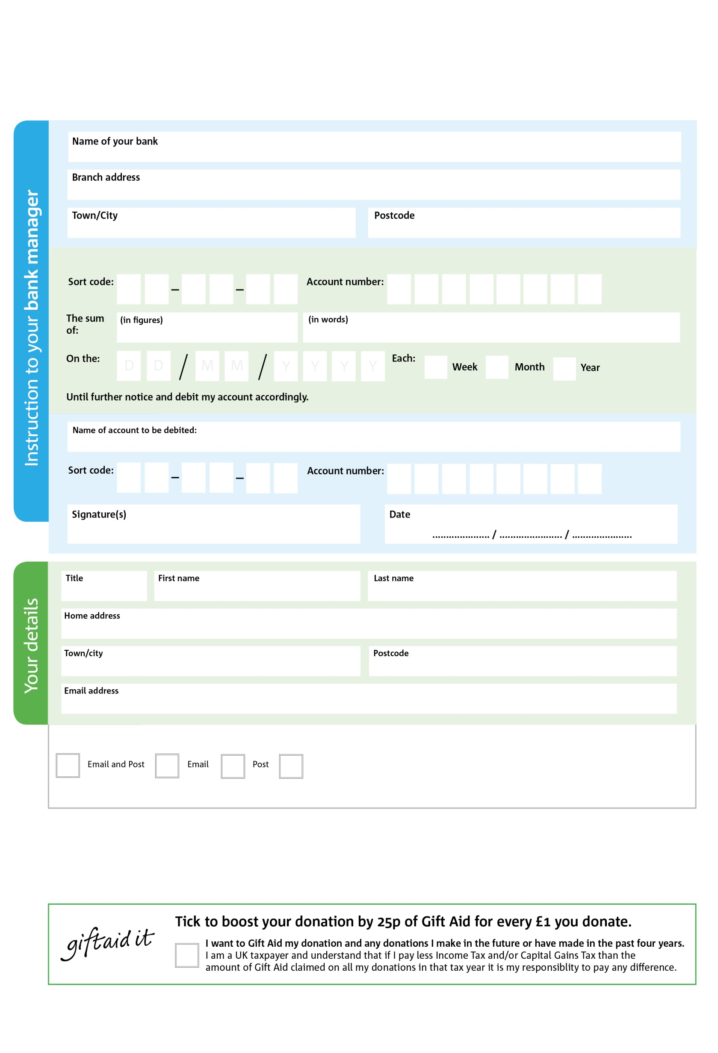

POSTAL ADDRESS: Clay Cross Foodbank, Community of Christ, Thanet Street. Clay Cross. S45 9JS

Reg. Charity No:247928 | Reg. in England & Wales

8

V

7

V

2

V

2

V

2

V

0

V

0

V

0

V

**Please pass this form onto the foodbank, using the foodbank’s address at the bottom, who will save a copy for their records.   
They will then send it onto your named bank or building society.**

0

4

2

5

0

4

We would love to keep you up to date with information aboutClay Cross Foodbank. Please tick your preference:

You can change your preferences any time by contacting us on 07899878398 or emailing us at info@claycross.foodbank.org.uk

I do not wish to receive future communications from Clay Cross Foodbank

Please pay Clay Cross Foodbank,

**Data protection**

Clay CrossFoodbank is committed to protecting your privacy and will process your personal data in accordance with the Data Protection Act 1998. Clay CrossFoodbank collects information to keep in touch with you and supply you with information relating to our work. Clay Cross Foodbank will never sell or pass your details to anyone who isn’t directly working on our behalf. A full data privacy statement for financial donors is available from the foodbank on request.

**Standing Order Mandate**

**www.claycross.foodbank.org.uk**

You can change your preferences any time by contacting us on XXXXXXXXXXX or emailing us at XXXX@XXXXXXXXXX.foodbank.org.uk

I do not wish to receive future communications from XXXXXX Foodbank